
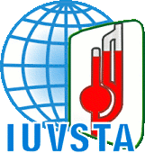
65th IUVSTA Workshop
Measuring molecular adsorption at solid-liquid interface
14th to 18th May 2012 at Peckforton Castle, Cheshire, UK

APPLICATION FOR AN INVITATION TO 65th IUVSTA WORKSHOP
Due to the limited number of places, attendance at this workshop is restricted. To register your interest in receiving an invitation from the organising committee please complete this form.

I WOULD LIKE TO PARTICIPATE IN THE 65th IUVSTA WORKSHOP

Name: |  |  |  |  |  |  |  | Title:
Institution:
Tel: |  |  |  | FAX: |  | E-mail
Proposed title of the presentation at the Workshop:
Please specify your intended presentation: |  |  | Attendance only

The completed application form should be sent to santanu.ray@npl.co.uk

